General Information Section
Venue Name and Address:
Donald M. Gay Performing Arts Center
Edward Little High School, 77 Harris St, Enter by Western Ave - Auburn Heights Rd, Auburn, ME 04210
Capacity:
1,200 seats total
Parking:
600 parking spaces
Load In: Street-Level Load In Door, Out Back.
Seating Breakdown by Level:
Lower theater level (1st floor): 388 seats
Upper theater level (1st floor): 356 seats
Balcony (2nd floor): 396 seats
Seating Breakdown by Type::
Fixed Seats: 1,140
Designated Wheelchair Spaces: 10
Box Seats (Removable & ADA-Accessible): 18
Box Seats (Removable, Not ADA-Accessible): 10
Total = 1,178 Spaces
Overflow Seats (Not Available for Ticketed Performances): 22
Total Capacity = 1,200
Seating Charts
First Level Theater Chart
Balcony Seating Chart
Accessible Seating
The Donald M. Gay Performing Arts Center is designed to be fully accessible to all guests, ensuring a comfortable and inclusive experience.
The auditorium spans three levels:
Lower Theater Level: Fully wheelchair accessible with six designated wheelchair spots (BB2, BB1, M103, M104, M107, M108).
Upper Level: Accessible via a wheelchair lift, with two designated wheelchair spots (V5, V7).
Balcony: Accessible by elevator, with two designated wheelchair spots.
Additional WC Spots: The following seventeen box seats are removable for WC Access: Lower Level X8-10, Y1-10. Balcony AA2-3, AA6-7.
Total wheelchair spots: 27
Seating & Mobility Features:
Adjustable Armrests: The smaller Handicap symbol on the seating chart indicates a fixed seat with an adjustable armrest.
Understanding the Handicap Symbols
Large Handicap Symbol: Indicates a dedicated wheelchair space—these seats are fully accessible.
Smaller Handicap Symbol: Indicates a fixed seat with an adjustable armrest. These seats are not wheelchair-accessible, but they offer additional room for guests who may benefit from a wider seat or easier access.
Wheelchair Access to Stage: The stage is wheelchair accessible from both back stage left and stage right. As well as stage right from the audience.
Visual & Hearing Assistance:
Side Stage Safety Lighting: Designed to assist those with visual impairments.
Assistive Listening Devices: Available upon request to enhance the experience for patrons with hearing impairments.
Illuminated Aisles and Stairs: Safety lighting throughout ensures clear visibility and secure movement for all guests.
Premium Box Seats:
Lower Level Box Seats: Rows X1–10 and Y1–10
Balcony Box Seats: Rows AA1–4 and AA5–8
These seats are all removable and can be configured as VIP seating or additional ADA spaces as needed. Please note: Seats X1–7 are not ideal for wheelchair access due to limited maneuverability. Seats A1, A4, A5 & A8 are fixed and not removable for ADA.
All other box seats are well-suited for conversion to ADA or VIP use and are often sold at premium pricing for their comfort, space, and sightlines.
Overflow Seating:
We can accommodate up to 12 additional guests by placing temporary chairs behind Rows L1–13 and L2–14. These are used only during sold-out or school-sponsored events.
Stage Dimensions:
ELHS Stage Blueprints
Main Stage: 85’-4” x 34’-7” (2,950 sq. ft.)
Apron: 85’-4” x 6’-7” (561 sq. ft.)
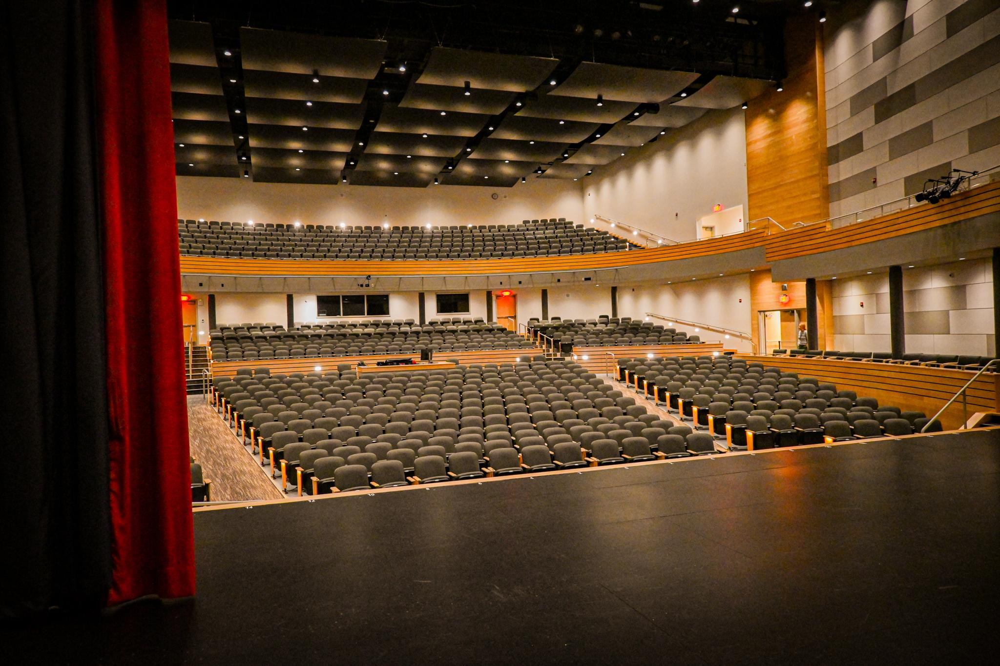
Total stage area: 3,511 sq. ft.
Height of Stage: 3ft 6 inches from floor level to stage level
Height from stage floor to bottom of steel: 49ft
Stage is wheelchair accessible and features optional safety lighting for individuals with visual impairments.
Stage Section Drawing:
ELHS Stage Section Drawing

Stage & Rigging

Rigging System Info

Architect: Harriman, Portland, ME
Structural Engineer: Harriman, Portland, ME
Theater Consultants: Theatre Projects, Norwalk, CT
Rigging Installer: High Output, Canton, MA
Installation Date: October 2023
Type: Counterweight system with assist motors on select lines.
Number of Line Sets: 27
Line Set Details:
ELHS LineSet Schedule 2024
ELHS Stage & Line Set Measured

Rigging Points
General Purpose Lines: Available at lines #7, #9, #13, #14, #18, #19, and #26 for additional rigging or purposes.
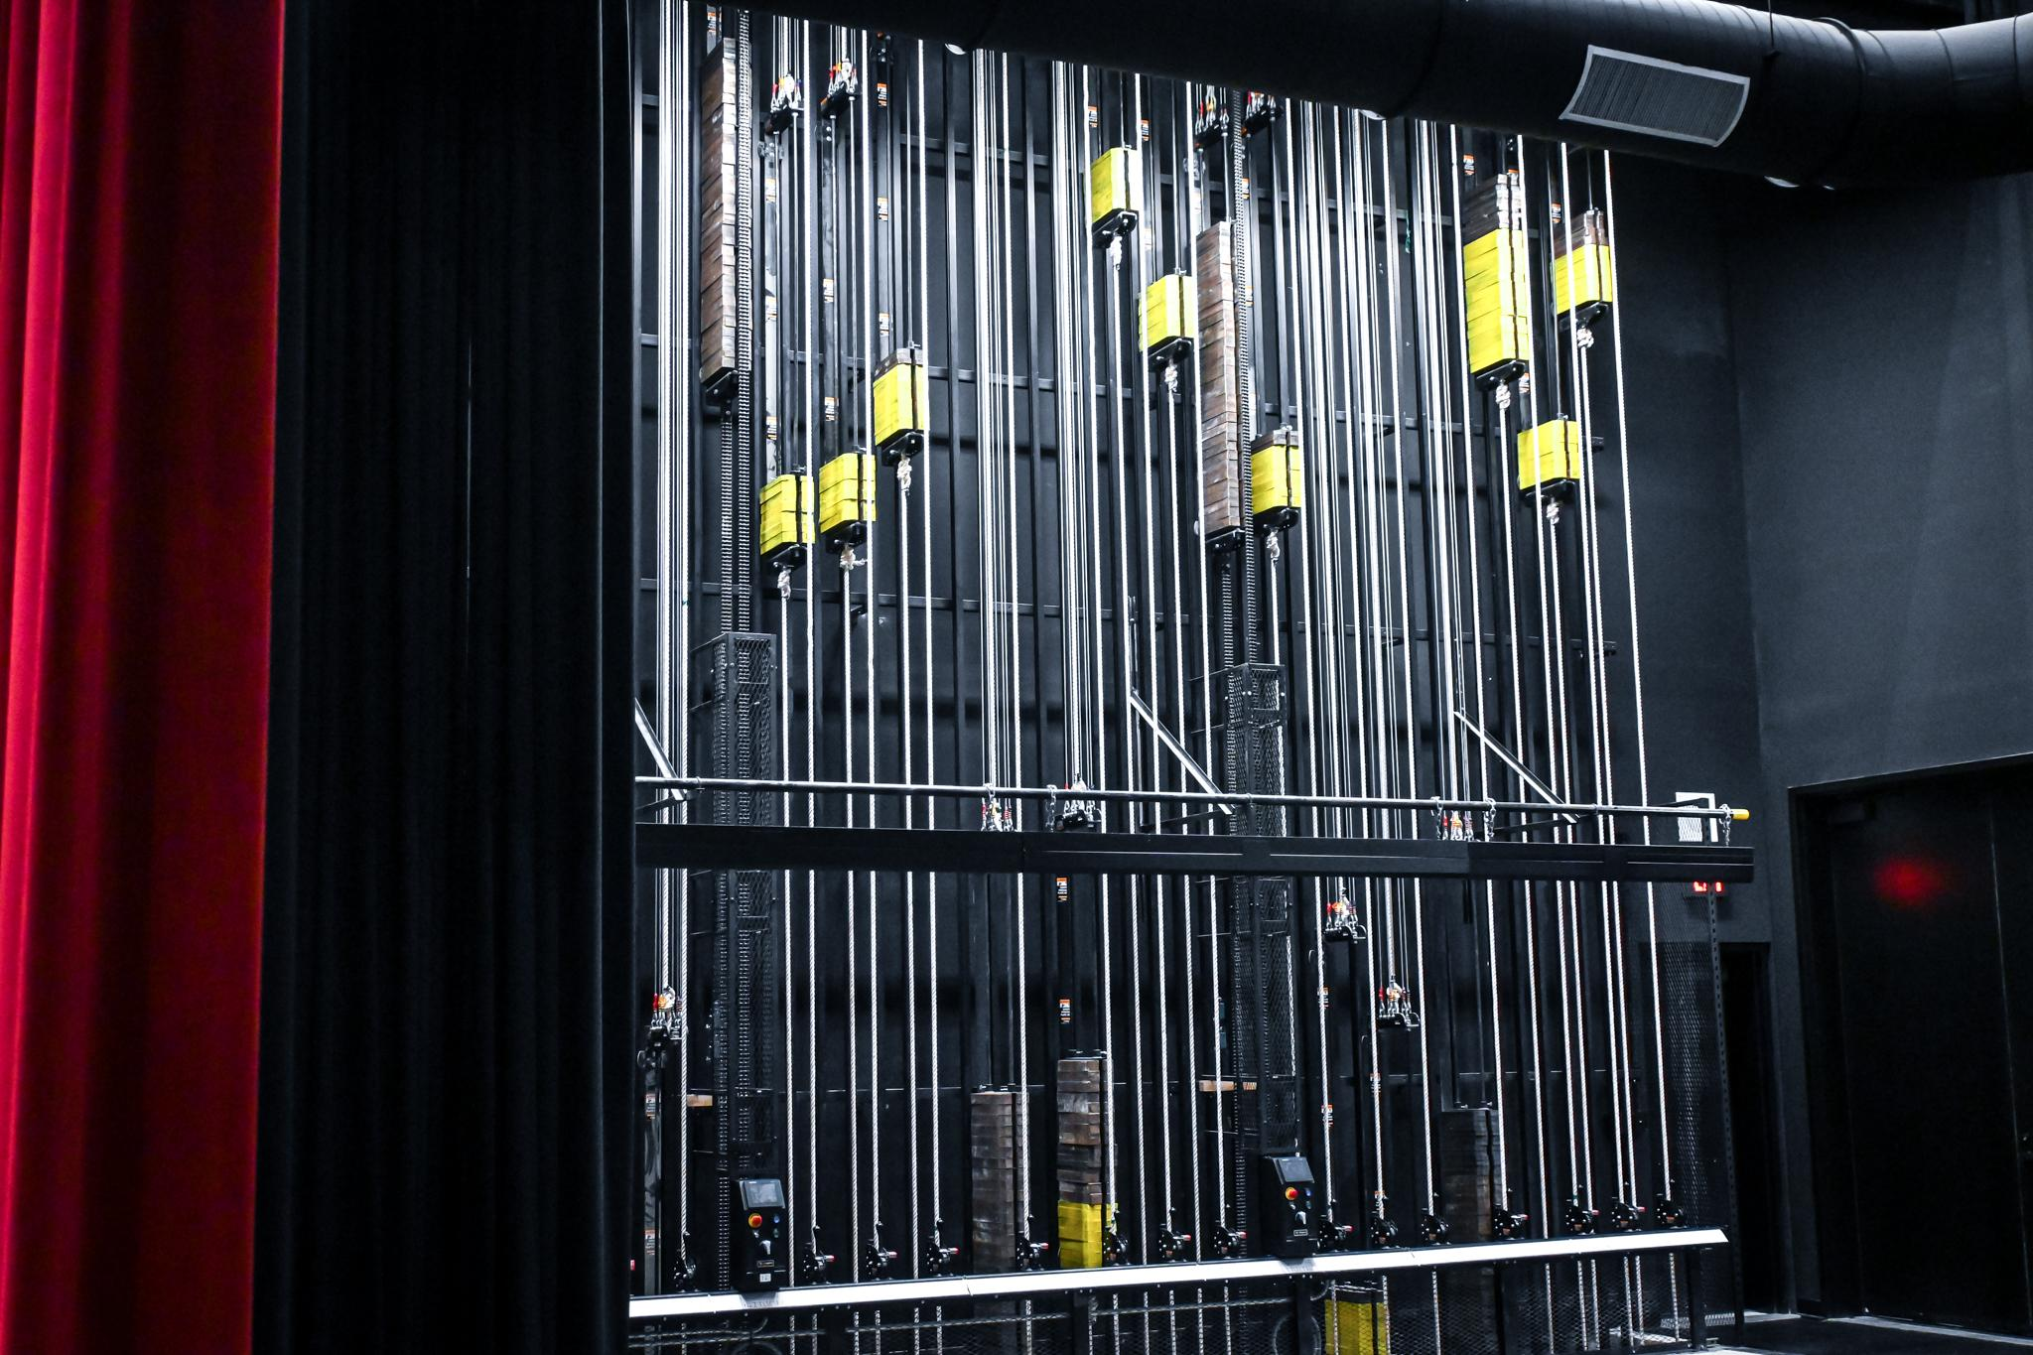
Counterweight System
1 inch x 6 inch Nominal Weights: 22.00 pounds
2 inch x 6 inch Nominal Weights: 44.00 pounds
1 inch x 4 inch Nominal Weights: 14.00 pounds
2 inch x 4 inch Nominal Weights: 28.00 pounds

Arbors
7-foot 0-inch Arbor:
4-inch Weights Capacity: 1009 pounds
6-inch Weights Capacity: 1564 pounds
9-foot 0-inch Arbor:
4-inch Weights Capacity: 1345 pounds
6-inch Weights Capacity: 2086 pounds

Wire Rope Lift Cables
Safe Working Load: 250 pounds per cable
Cable Specification: 1/4 inch, 7 x 19 strand aircraft cable
Breaking Strength: 7,000 pounds

Load Capacities
Fly Gallery Floor Load: 150 pounds per square foot
Fly Gallery Pin Rail: 250 pounds per square foot
Loading Gallery Floor: 600 pounds per square foot
Maximum Total Live Load on Loading Gallery: 60 pounds per square foot
Additional Notes:
Weight should be distributed evenly over the gallery.
Do not stack weight over 12 inches high.
Avoid overloading.

Shell & Curtains

Acoustic Shells
Location: Acoustic shells are available at line sets #8, #16, and #24 (Manual Counterweight).

Cyclorama
Type: White-filled scrim made of flame-retardant polyester.
Location: Positioned at line #27 (Manual Counterweight, 30'-0").

Scrim
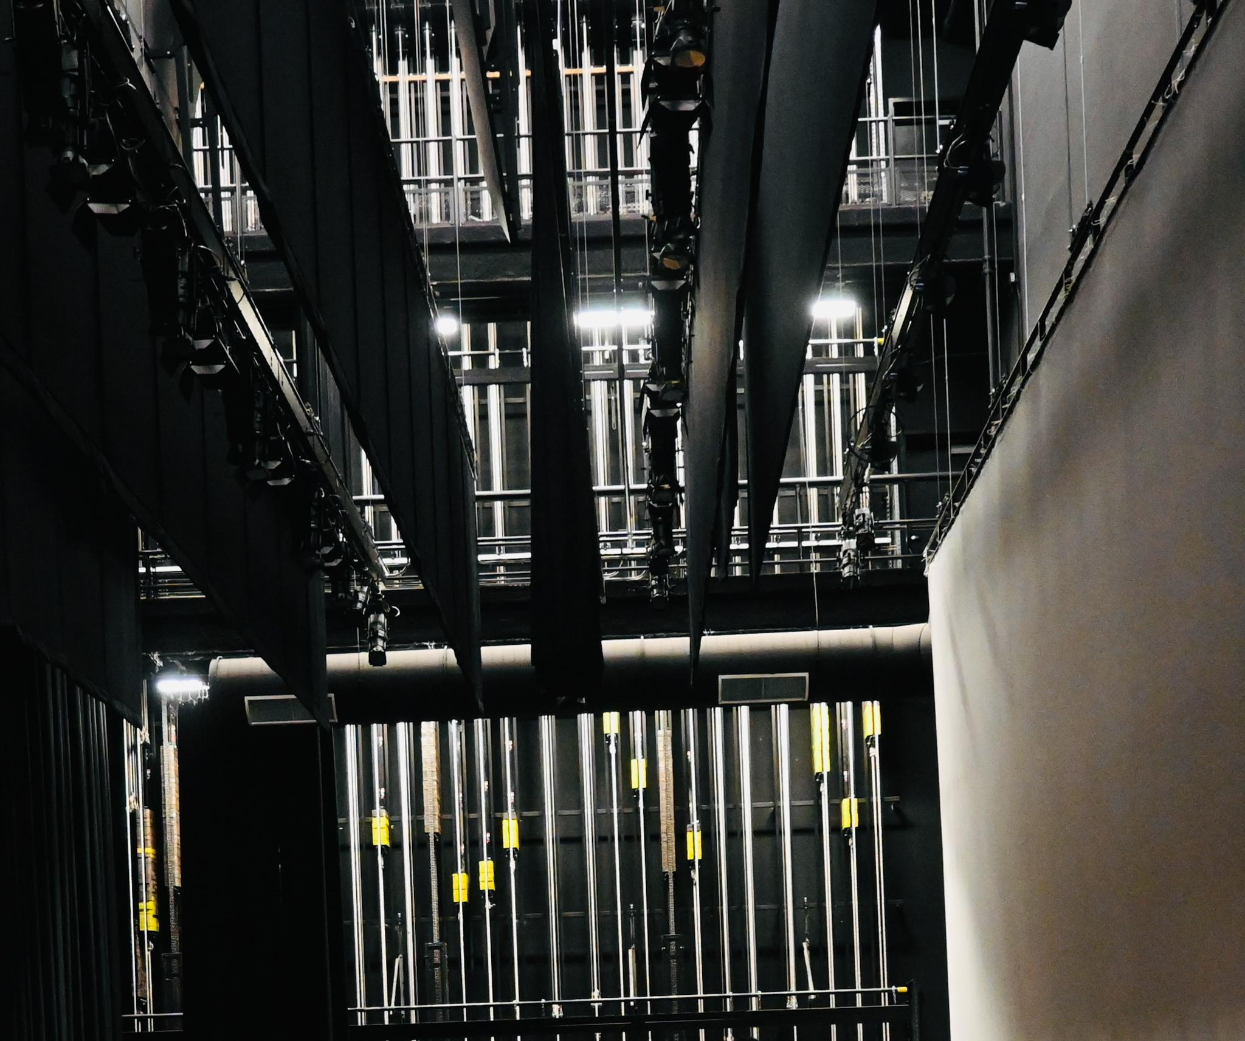
Type: Black scrim made of inherently flame-retardant (IFR) velour.
Location: Positioned at line #23 (Manual Counterweight, 23'-11").

Travelers
Main Curtain: Located at line #2.
Traveler Curtain: Located at line #17.

Stage Floor Specifications
Stage Floor Composition: Material: Sprung floor made of two layers of 3/4 inch OSB (Oriented Strand Board) plywood. With Plyron on top which is essentially a layer of (hardboard) or Masonite adhered to plywood. Clearance: 3-inch clearance to the cement base.
Orchestra Pit: The auditorium does not have an orchestra pit. Orchestras can be set up in the aisles on stage left or right or on the ground floor in front of the stage with the removal or Rows AA & BB (center, front 2 rows).

Stage Accessibility Features
Access to Stage for Disabled Performers: The stage is fully accessible to performers without the need for a ramp or elevator, with entry available from backstage to both stage right and stage left. Safety lights are installed along the edges of the stage, which can be turned on or off as needed. The backstage area is equipped with blue lighting and other options to ensure visibility during performances.

Automation & Special Effects
Automation Systems: All rigging systems in the auditorium are manual, with some lines equipped with counterweight assist. The only automated system is the projector.
Special Effects Systems: Requests for the use of fog machines, pyrotechnics, or other special effects will be reviewed by the school on a case-by-case basis.
Curtains, Legs & Borders
Black Curtains:
Material: Encore 64 IFR, 22 oz, Black
Composition: Inherently flame-retardant polyester with a matte, velour-like finish for effective light absorption.
Red Main Curtain:
Material: Prestique Velour 54 IFR, 25 oz
Composition: Inherently flame-retardant (IFR) fabric with a plush, velour texture, providing a luxurious appearance suitable for a main stage curtain.
All curtains, borders, legs, and masking elements are inherently flame-retardant, ensuring safety and compliance with fire regulations.
Clearance Heights
Clearance from Stage to Grid: The height from the stage floor to the grid/fly system is 35'-7". This is the vertical clearance for anything that can be flown in or out, including scenery and lighting.
Proscenium Arch Clearance: 21ft 6 inch

Communications & Monitoring
Communication System (Intercoms): The auditorium is equipped with an intercom system, with stations located in the A/V box and backstage on stage right.
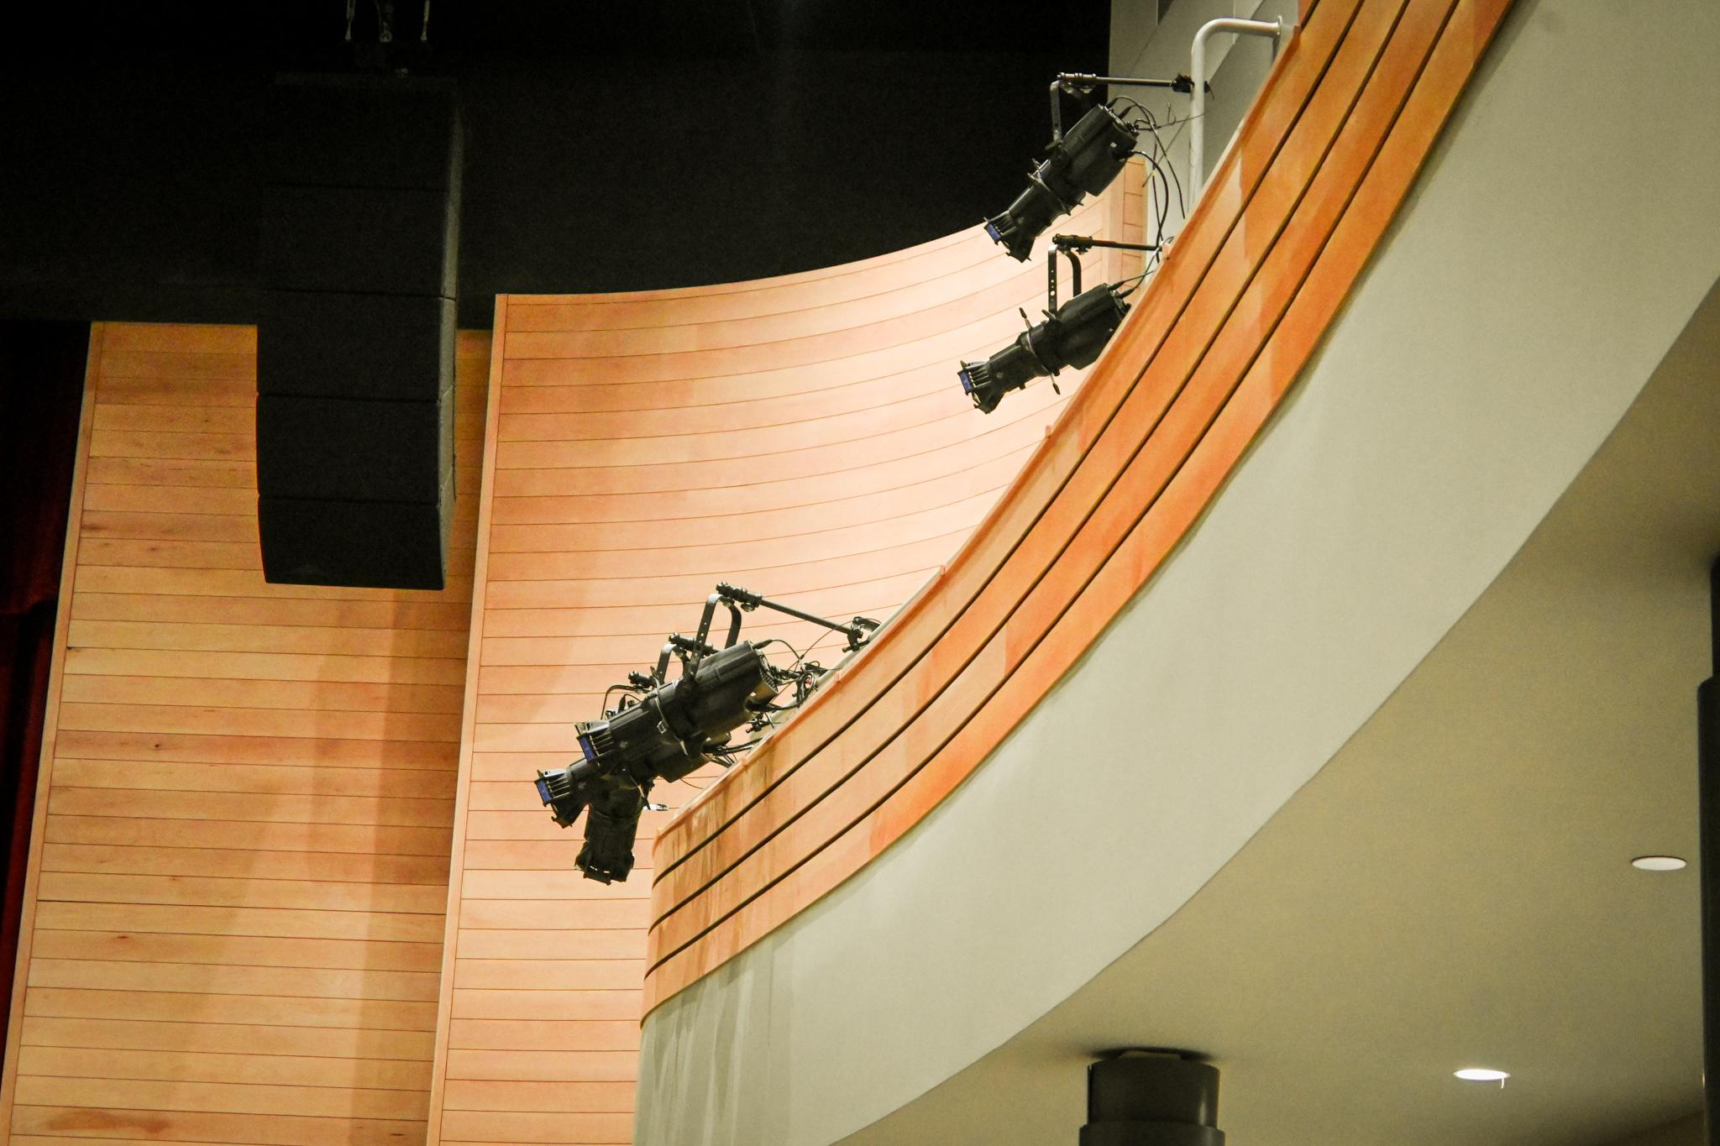
Video Monitoring: Video feeds are available in the auditorium for monitoring the show from backstage, the green rooms, the A/V room, and the lobby, providing visibility for stage management and other staff.

Spare Line Sets for Scenic Elements
Line Sets: Available at lines #7, #9, #13, #14, #18, #19, and #26 for additional rigging or purposes.

Lighting

Lighting & System

Edward Little Light Plot 2024: See Light Plot Schedule for more information.
Lighting Positions:
- FOH Catwalk
- Balcony Rail
- Box Booms (Left & Right)
- Box Rail (Left & Right)
Electrics:
No. 1 Electric
No. 2 Electric
No. 3 Electric
No. 4 Electric
Stage Booms (Left & Right): Pipe & Base are available as needed (8 total).

Lighting Console
Console Type: ETC Element 2
Control Locations:
Lights can be controlled via the A/V room, the theater A/V table in the lower level, and backstage.
The house lights and basic lighting functions are available through a separate pre-set touchpad system, eliminating the need to use the lighting board for basic A/V operations. The lighting board is reserved for advanced productions.
Heading Lighting System
Consists of 288 ETC IQ Relays.
Lighting Fixtures
ETC ColorSource Spot Deep Blue:
20 units (CSSPOTDB 410 LT)
14 units (CSSPOTDB 419 EDLT)
16 units (CSSPOTDB 426 EDLT)
32 units (CSSPOTDB 436 EDLT)
6 units (CSSPOTDB LED50LT)
ETC ColorSource PAR:
30 units, with accompanying lens kits and barn doors.
ETC ColorSource CYC:
7 units for lighting the cyclorama.
Followspots:
2 Strong Ultra ArcSeries II followspots.

Lighting Accessories
Lens Kits: Set of 7 diffusion lenses for ColorSouce PAR.
Barn Doors: 35 units (6” 4-way).
Top Hats: 44 units for 19-90 degree ellipsoidals.
Half Hats: 44 units for 19-90 degree ellipsoidals.
Drop-in Iris: 2 units.
Pattern Holders: 8 units (A-size).

Additional Rigging Accessories
Side Arms: 30 units (18” with 2 tees).
Boom Tie Offs: 6 units with SSRC 50 lb stationary lighting base.
House Lights
Control: House lights are controlled from the booth and include zones such as upper sides, lower sides, under the balcony, and front of the house.
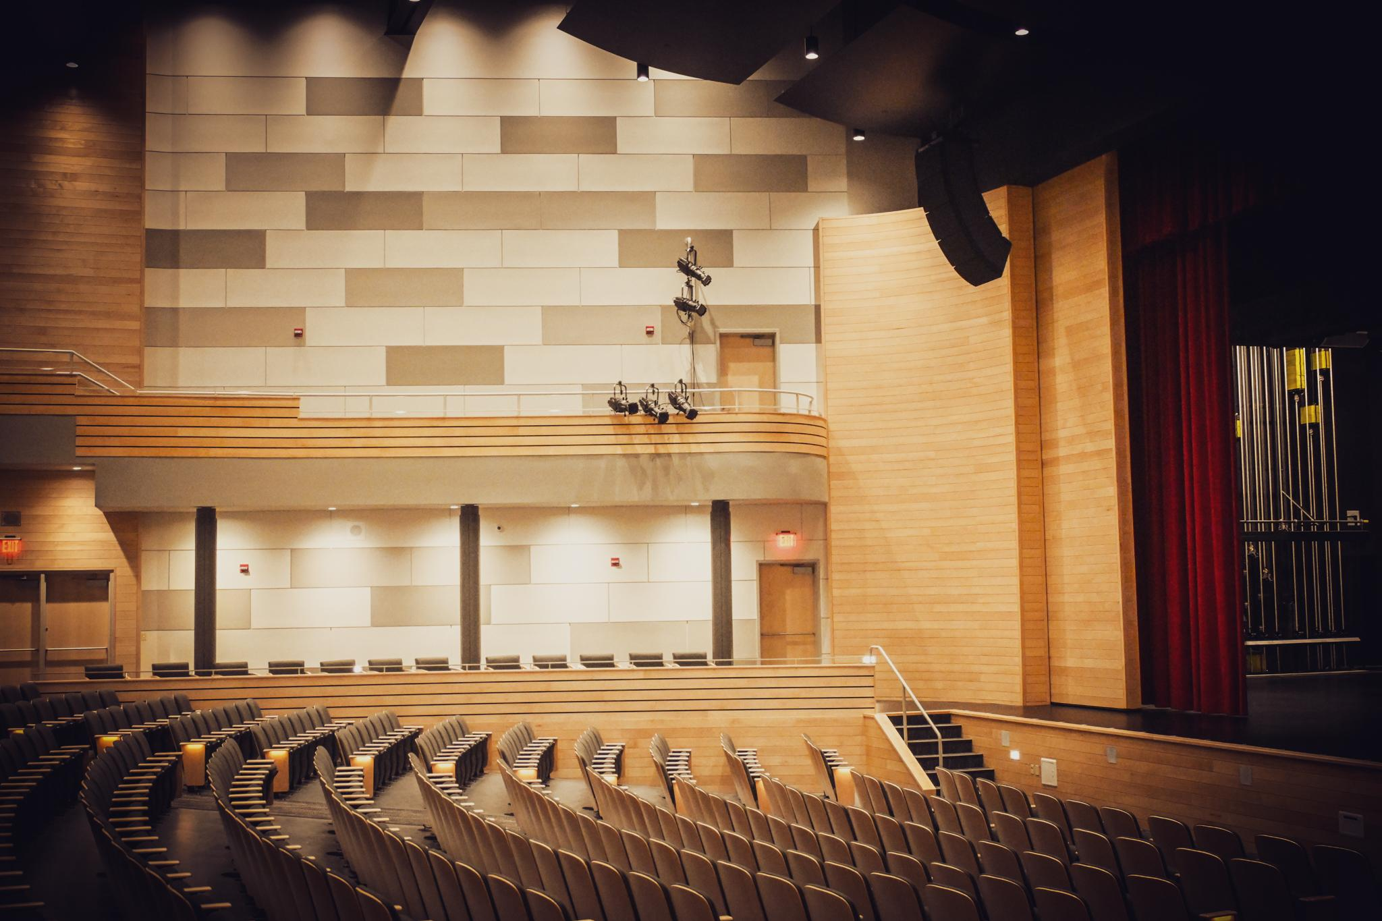

Sound

PA System

Microphone Types:
Shure ULXD2/ SM58 Wireless Handheld Transmitters – 5 units
Point Source EO-8WL-XSH-BE Ear-mount Lavalier Microphones – 20 units
Shure ULXD1 Beltpacks – 20 units
Microphone Accessories:
Microphone Stands
Microphone Podium
Lavalier Accessories: Ear Mounts & Lapel

Speaker Placement
Main Speakers: Left and right line array speakers positioned above the apron.
Subwoofers: Two subwoofers in a center cluster positioned above center stage.

Optional Monitors
Stage Right: Monitor plug-ins at positions Pit 1 & 2.
Backstage Right: Monitor plug-ins at positions 5 & 6.
Stage Left: Monitor plug-ins at positions Pit 3 & 4.
Backstage Left: Monitor plug-ins at positions 7 & 8.
Fly Gallery: Additional option to connect a monitor.

Mixing Console
Console: Allen & Heath SQ-7
EOS Soundboard Equipment: Equipped with advanced EOS sound board features, allowing for complex audio control and customization.
Channels: Capable of handling a high volume of inputs for complex sound setups.

Assistive Listening
System: ListenTech LT-803-072-01, a 3-channel RF transmitter.
Receivers: 40 ListenTech LP-51-072-01 receivers, plus 3 ListenTech LR-5200-072-P1 DSP receiver packages for enhanced audio accessibility.

Audio/Visual Equipment
Projectors: 1 Panasonic PT-RZ16KU projectors with ET-D75LE20 and ET-D3LEW10 lenses for high-quality projection.

Additional Equipment
Cables: A selection of Whirlwind Speakon and CAT6 Ethercon cables, ranging from 3 to 100 feet for flexible audio setups.

Sound Projection Capabilities
Extended Audio Projection: Sound can be projected to hallways, lobby, and band rooms, ensuring clear communication across venue areas.

System Power and Backup
Power Supply: Information about any uninterruptible power supplies (UPS) or backup power systems for critical sound equipment.
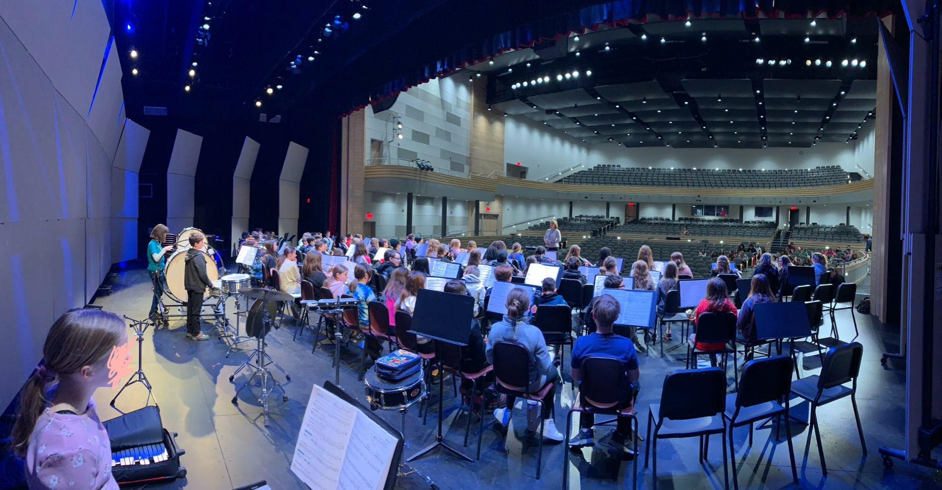

Intercom System
Intercom: The auditorium is equipped with an intercom system, with stations located backstage, in the audience area, and in the A/V room, facilitating seamless communication among tech crew members during events.

Sound Settings/Presets
Preset Profiles: The auditorium features a preset audio setting accessible on a digital pad, enabling basic microphone use without requiring the sound board. This setup allows for easy volume adjustments, ideal for straightforward audio needs without complex mixing.

Audio Playback
System Setup: Music and sound effects can be played directly through our computer setup connected to the sound system, ensuring seamless integration of digital audio files into live performances and events. Audio playback is also possible through the soundboard, offering additional flexibility and control.
Software: The system utilizes QLab, a professional multimedia playback software, to manage and cue audio files. QLab supports precise control of music, sound effects, and other audio elements, making it ideal for theater productions, concerts, and presentations.

Environmental Acoustics
SoundCloud Ceiling: Acoustically treated sound cloud ceiling above the audience for optimal sound quality.
Stage Sound Shell: Additional sound shell rigged for improved acoustics.
Portable Sound Wall: Installable sound wall available for enhanced acoustic control as needed.

Projection & Media

Projectors
Model: 1 Panasonic PT-RZ16KU projectors
Lenses: Equipped with ET-D75LE20 and ET-D3LEW10 lenses for high-quality projection across the stage and screen area.
Settings: Resolution set at 1920x1080p, 60Hz, with a 16x9 screen size.

Connection Points
Input Options: Includes HDMI, VGA, and Apple TV screen mirroring for connecting laptops, media players, or other devices.
A/V Control: Projection is controlled from the A/V table, room, on stage or backstage for optimal management.

Additional Media Features
Playback Device Compatibility: Supports external devices for media playback.
Live Streaming: Not hooked up for live streaming.

Power & Electrical

Stage Power
General: See Circuit Schedule for theatrical relay outlet locations.

Backup Power
Generator: Provides backup power for emergency lighting, heating & cooling only.
Emergency Lighting Transfer System: Model ELT32.
Orange Sockets: Any outlet marked with an orange socket is connected to the generator and will function during an outage.

Backstage & Dressing Rooms

Dressing Rooms
Rooms: Two dressing rooms equipped with lights, mirrors, and sinks.
Restrooms: Bathroom located backstage in the hallway for convenience.

Green Room Options
Available spaces include the band and choir rooms, classrooms, gym, or cafeteria, depending on the event's needs. The band and choir rooms also include audio & video monitors from the stage.
Loading Dock & Access
Loading Dock: Accessible through Door # (to be confirmed) or the garage doors via the LRTC fire school. Advance arrangement is required through the LRTC program for use of the garage. All loading doors are at street & stage level.
Direct Stage Access: Wheelchair-accessible entrances are available via backstage left and right.

Additional Backstage Amenities
Monitors: TV monitors can be set up in the A/V room and backstage for onstage monitoring.
Limited Storage: Dedicated tech space for sorting pieces, along with designated prop and costume rooms.

Safety and Accessibility

Accessible Seating & Access
Three Levels:
Lower Theater Level: Wheelchair accessible with 8 designated wheelchair spots.
Upper Level: Accessible by wheelchair lift, with 2 designated wheelchair spots.
Balcony: Accessible via elevator, with 2 designated wheelchair spots.
Adjustable Armrests: End chairs in each inner row feature pull-out armrests, providing additional space for those who require it.
Wheelchair Lift
Type: Garaventa Lift
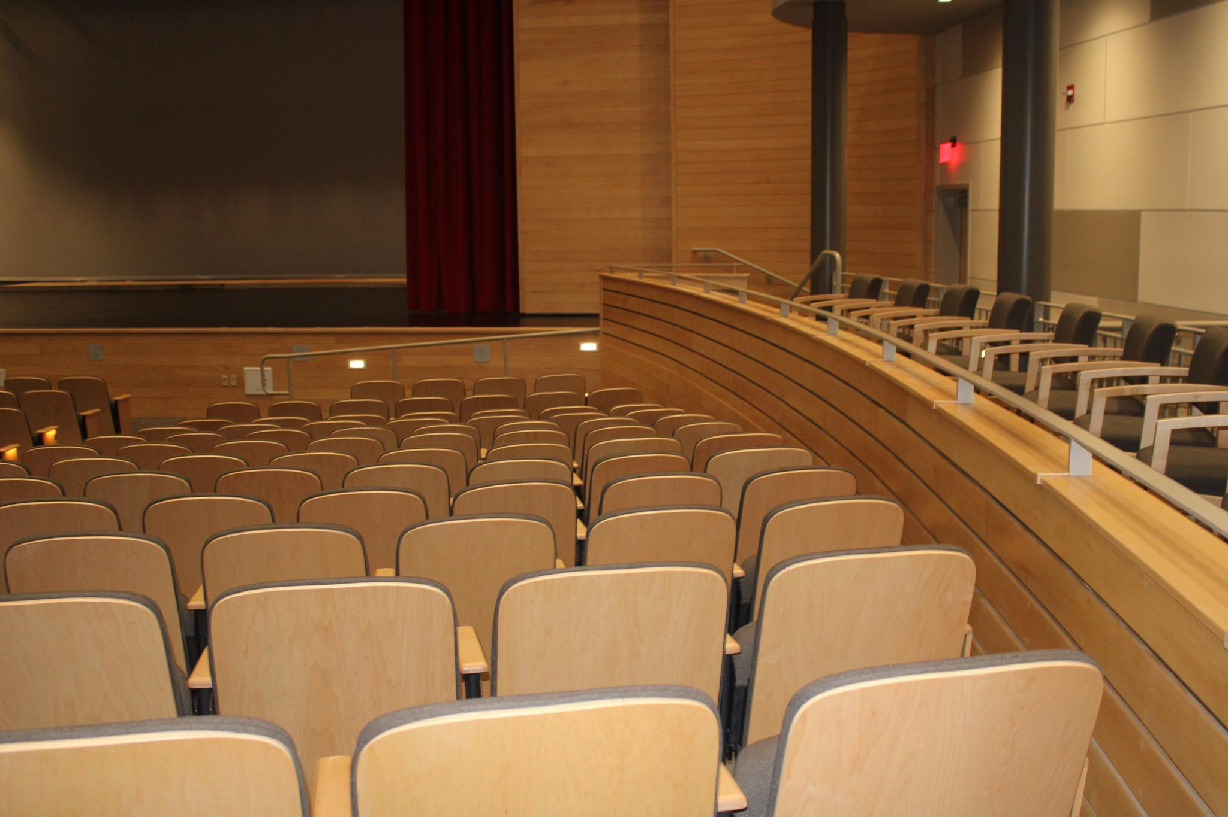
Max Capacity: 750 lbs
Access: Provides access to the upper theater level & A/V Control room, ensuring accessibility for patrons/tech crew with mobility needs.

Onstage Accessibility
Wheelchair Access: Wheelchair access is available on stage, with accessible entry points on both stage left and stage right.
Safety Lighting: Side stage safety lights assist those with visual impairments.

Assistive Listening Devices
Hearing Assistance: Devices are available to assist patrons with hearing impairments, ensuring an inclusive experience.

Illumination for Safety
Aisle and Stair Lighting: All aisles and stairs are equipped with safety lighting for clear visibility and secure movement.

Additional Accessibility Features
Visual Impairment Aids: Safety lights and marked pathways enhance visibility for attendees with visual impairments.

Fire Exits & Safety
Fire Exits: There are four fire exits on the lower level, two on the upper level, and three in the balcony for safe and accessible egress throughout the auditorium.
Fire Hose: Located at the front of the back stage on both the right and left sides.

Special Effects Policy
Approval for Effects: Outline that fog machines, pyrotechnics, or other special effects require prior approval through the school on a case-by-case basis.

Additional Equipment and Amenities

Podiums
Speaker Podium: Available for presentations and speakers.
Conductor's Podium: Available for musical performances and conductors.

Seating and Staging Equipment
Chairs and Tables: 8ft tables and additional chairs available for event setup.
Music Stands: Available to borrow for performances.
Choir Risers: Provided for choral performances.
Grand Piano and Keyboard: Yamaha S7X grand piano available for musical performances.

Orchestra Setup Options
Orchestras can set up by removing the first two rows of seating or using designated areas on stage left or stage right.

Safety and Support Staff
Emergency Contact: Lilly Gardiner, 207-607-2978.
Technical Support: A/V technicians available for lighting and sound design and operation.
Event Staff: Ushers, parking attendants, stagehands, and event managers can be sourced as needed.
First Aid Kits: First aid kit is located stage left for quick access during events.

Concessions, Box Office, and Lobby Amenities
Concessions Stand: Available for rental.
Box Office: Rentable for ticket sales and event management.
Lobby: Equipped with TVs displaying live stage activity, with areas for photography (step and repeat), and a spacious layout for mingling with private event bathrooms.

Catering
Catering: Outside catering is allowed. In-house catering options are also available through The Green Ladle at LRTC.

Ticketing Platform
In-House Ticketing: The venue has its own ticketing platform, allowing event organizers to buy and sell tickets, with in-house ticket printing capability.
Climate Controlled Seating:
The auditorium features a climate-controlled environment, ensuring comfortable seating conditions for all audience members regardless of the season or weather. Temperature is regulated throughout the lower and upper theater levels, as well as the balcony, providing a consistent and comfortable atmosphere during events.

